Website Project Proposal (Parts 1-3)
CleanCoast Cape Town - Web Development Portfolio of Evidence
Student Name: Qayiya Ngxamngxa
Student Number: ST10510290
Module Code: WEDE5020POE
Module Name: Web Development (Introduction)

PART 1: Project Initiation and Planning (Completed)
1. Organisation Overview
Name: Clean Coast CPT - Be a part of the Wave of Change
Brief History: Clean Coast CPT was founded at Muizenberg Beach in early 2020 by a group of passionate surfers who decided to make a difference after observing the increasing plastic pollution on the beach during their daily surfing sessions. Originally it was nothing more than a WhatsApp group sharing information regarding clean up days. The organization quickly gained traction and supporters when they managed to collect over 300kg of garbage during the "2022 Atlantic Clean-Up". Soon after they created their website to facilitate volunteer sign-ups, monthly "Trash-Bashes" and monthly workshops focusing on educating Capetonians on the importance of protecting and preserving our beaches and marine life.
Mission Statement: To create a clean and safer space for marine and human life alike.
Vision Statement: To decrease marine plastic pollution from its approximate 80% to 50% by 2035.
Target Audience:
- Local residents of Cape Town who want to volunteer
- Schools and educational institutions
- Tourists who want to give back to the community
- Corporate sponsors looking for environmental initiatives
- Environmental organizations and conservation groups
2. Website Goals and Objectives

Primary Goals:

We want to get more people to sign up to be volunteers for the beach clean-up drives.

The beach clean-up drives are what we are focusing on.

We also want to make people more aware of the problems caused by pollution.

The plastic pollution is an issue that we need to address.

We need to get more people to visit our website so they can learn about the events and workshops we are having.

The events and workshops will help us develop a community of people who care about the environment.

We are trying to develop an environmental community through the website.

Key Performance Indicators (KPIs):

We will measure the number of volunteer sign-ups.

The volunteer sign-ups for the beach clean-up drives should be than 50 per month.

We also want to see how many people visit our website.

The target for website visits is than 1000 visits per month.

Another thing we will measure is the attendance at our workshops.

We are aiming for than 30 people per session at the workshops.

We also want to raise money through donations.

The target for donation amount raised is R10,000 per quarter.

3. Current Website Analysis

Clean Coast CPT does not have a website right now.

They are using a WhatsApp group and social media to plan the cleanups.

This is not ideal because it limits the number of people they can reach.

New volunteers are also having a hard time finding and joining the group.

Strengths:

The community is very supportive on WhatsApp.

The clean-up events have been successful in the past.

We have dedicated volunteers who are helping out.

Weaknesses:

Not having a website means people do not know about us.

It is hard for people to find information, about Clean Coast CPT.

Volunteers are having a time signing up.

We are also having trouble sharing the things we are doing.

It is difficult to collect donations because we do not have a website.

The beach clean-up drives and the environmental community are suffering because of this.

4. Proposed Website Features and Functionality
Pages to Include:
Page | Filename | Purpose | Key Content
Home | index.html | First impression, navigation hub | Hero section, key statistics, donation progress bar
About | about.html | Tell the organisation's story | Mission, history, team members, values
Get Involved | get-involved.html | Volunteer and donate | Sign-up form, donation section, partnership info
Gallery | gallery.html | Showcase impact | Before/after cleanup photos with lightbox
Contact | contact.html | Contact information | Form, address, map, office hours

Functionality Features:
We have an accordion that shows information about each team member.
It is useful for team member bios.
The team member bios are easy to read.
We also have a gallery with a lightbox for our images.
This makes it easy to look at the images.
We have a donation progress bar, on our website.
The donation progress bar is dynamic.
This means the donation progress bar changes when people make donations.
Our website has form validation.
The form validation uses HTML5 and JavaScript.
This helps make sure people fill out the forms correctly.
Our website is responsive.
This means it looks good on all devices.
The website works well on all devices.
Our pages are optimised for search engines.
This means our website is SEO optimised.
The SEO optimised pages help people find our website.

5. Design and User Experience
Colour Scheme:
- Primary: #2d6a4f (forest green) - representing nature and growth
- Secondary: #f4a261 (warm orange) - representing energy and action
- Background: #f5f5f0 (warm white)
- Text: #2d2d2d (dark grey)
Typography:
- Headings: Arial, sans-serif (bold, clean)
- Body: Arial, 'Segoe UI', Tahoma, sans-serif
- Hierarchy: H1 (36px), H2 (28px), H3 (22px), Body (16px)
Layout and Design Approach:
- Clean, modern design with plenty of white space
- Card-based layout for information
- Consistent header and footer across all pages
- Mobile-first responsive design
- Accessible colour contrast

Low-Fidelity Wireframes:
Homepage Layout:

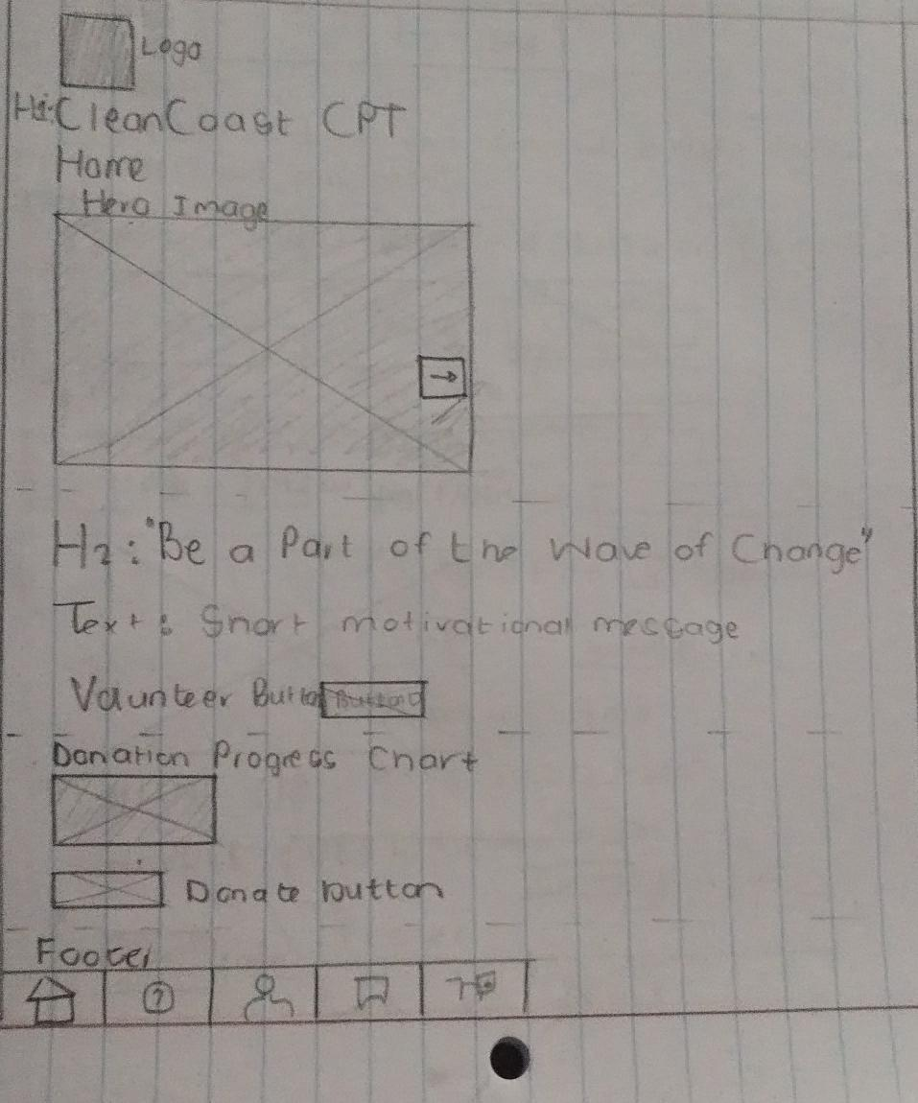

About Page Layout:
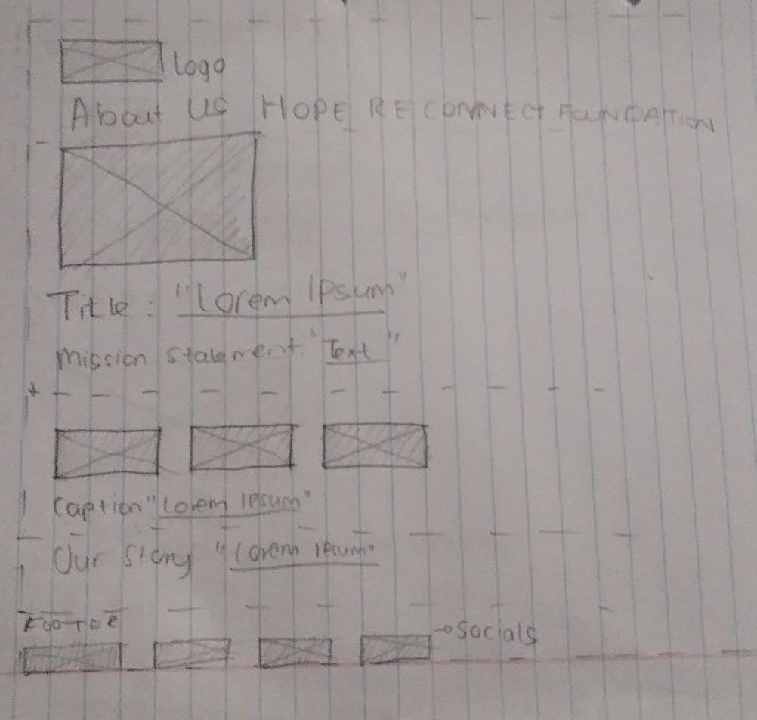

Gallery Page Layout:
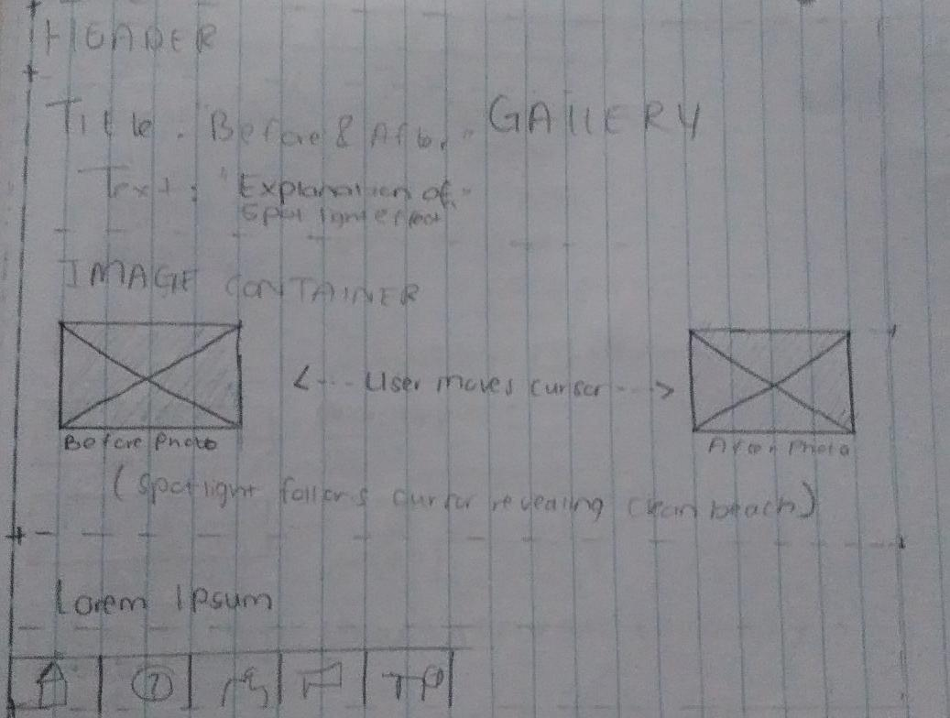

Get Involved Page Layout:
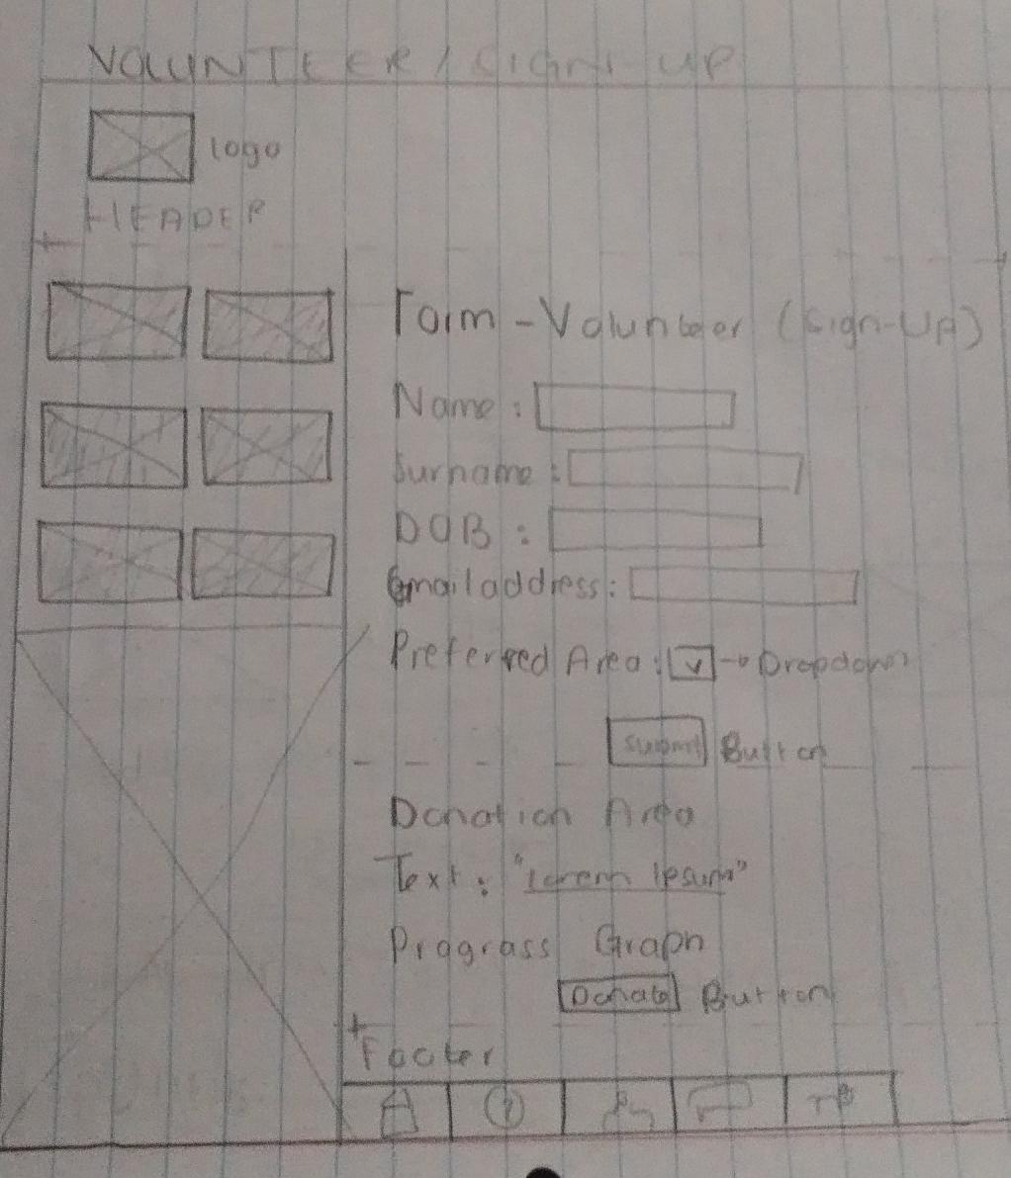

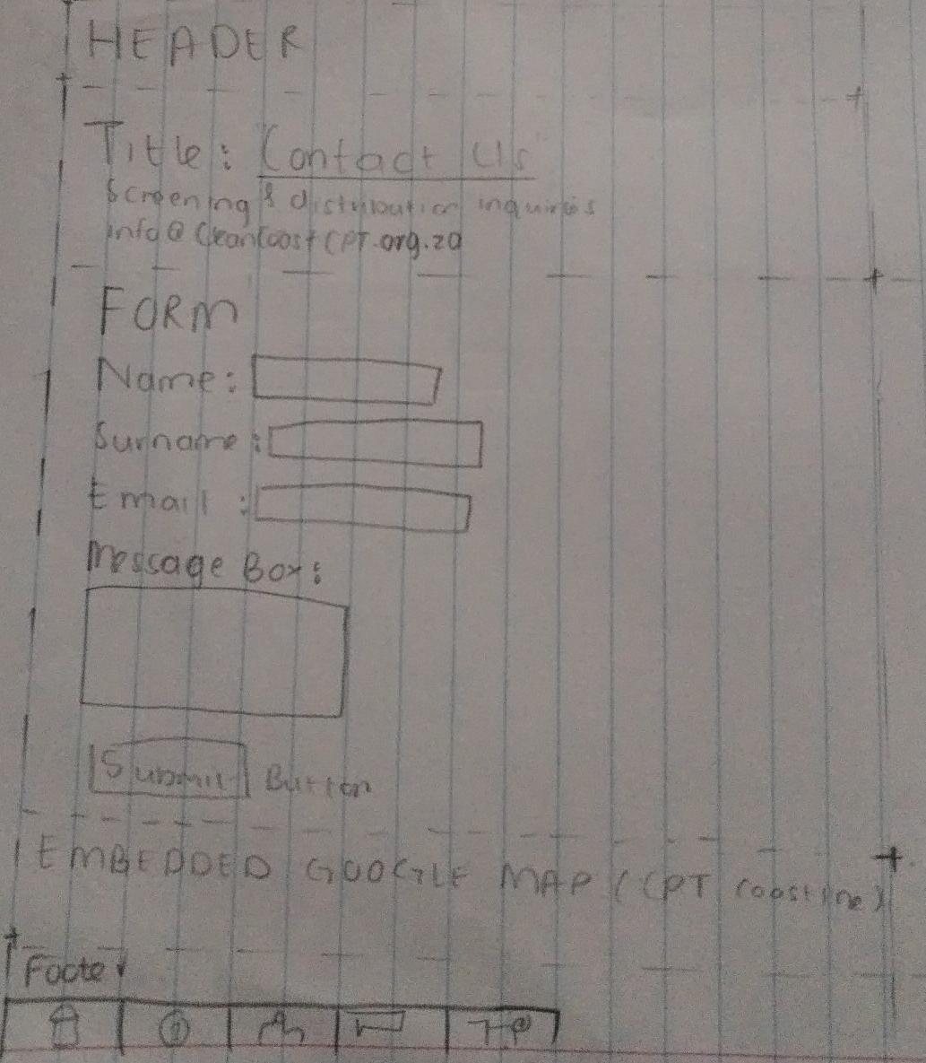
Contact Page Layout:

Sitemap:
CleanCoast Cape Town
│
├── Home (index.html) - front page, hero, facts, donation bar
│
├── About (about.html) - who we are, mission, story, team accordion
│
├── Get Involved (get-involved.html) - volunteer form, donate
│
├── Gallery (gallery.html) - before/after cleanup photos with lightbox
│
└── Contact (contact.html) - contact form, address, email, map

6. Technical Requirements
Languages:
- HTML5 - Structure and content
- CSS3 - Styling and responsive design
- JavaScript - Interactivity and functionality
Libraries and APIs:
- jQuery - For accordion and other interactive elements
- Google Maps API - For showing location
- Font Awesome - For icons
Development Tools:
- Visual Studio Code - Code editor
- Git - Version control
- GitHub - Repository hosting
- Chrome DevTools - Testing and debugging
Hosting:
- Netlify (free tier)
- Domain: cleancoast-cape-town.netlify.app
- 7. Timeline and Milestones
Phase | Milestone | Duration | Status
Part 1 | Research & Planning | 3 days | Complete
 | Write proposal and sitemap | 1 day | Complete
 | Build Core HTML structure | 4 days | Complete
Part 2 | Create external CSS file | 1 day | Complete
 | Desktop CSS styling | 2 days | Complete
 | Responsive design | 2 days | Complete
 | Cross-browser testing | 1 day | Complete
Part 3 | Add jQuery and accordion | 1 day | Complete
 | Add gallery lightbox | 1 day | Complete
 | Add Google Maps | 1 day | Complete
 | Add donation progress bar | 1 day | Complete
 | Forms with validation | 2 days | Complete
 | SEO implementation | 1 day | Complete
 | Deployment | 1 day | Complete
 | Documentation | 1 day | Complete

8. Estimated Budget

Category | Description | Estimated Cost (ZAR) | Frequency
1. Domain Registration | Purchase of .org.za domain name via Afrihost | R150 | Annual
2. Web Hosting & SSL | Shared or student plan with SSL | R0 | Netlify free tier
3. Development Resources | Student lab time (~90 hours) | R6,500 | Once-off
4. Images & Media Licensing | Stock photos from Unsplash/Pexels | R0 | Free
5. SEO & Analytics Setup | Google Analytics and Search Console | R0 | Free
6. Maintenance | Annual updates and content changes | R500 | Annual
7. Contingency Fund (10%) | For unexpected costs | R715 | Once-off
TOTAL |  | R7,865

PART 2: Designing the Visuals - CSS Styling and Responsive Design
1. Working through Feedback from Part 1
After receiving my marks and feedback for Part 1, I went through all the comments carefully and made the following corrections and improvements:
Area of Feedback | What I Was Told | What I Changed | Where to Find It
Project Proposal Structure | Need to follow formatting guidelines properly | Reformatted proposal with proper headings, subheadings, and consistent font (Aptos 11pt) | Proposal document
Wireframes | Wireframes were incomplete and lacked detail | Created more detailed wireframes for all 5 pages | Part 1 proposal document
Content Research | Content was insufficient | Added more detailed content to all pages | All HTML pages
HTML Structure | Need proper HTML5 semantic elements | Changed <div> to <header>, <nav>, <main>, <footer>, <section>, <article> | All HTML files
Navigation | Navigation links needed to work properly | Fixed all broken links | All HTML files
Comments in Code | Comments were missing or too vague | Added descriptive comments to all code | All HTML files
File and Folder Structure | Organisation needed improvement | Created proper folder structure | GitHub repository
GitHub Commits | Need more descriptive commit messages | Added detailed commit messages | GitHub repository
README.md | README was incomplete | Added comprehensive README | README.md file
References | References were incomplete | Added all references in correct Harvard format | README.md and proposal

Changelog
1. Project Proposal:
- Fixed formatting with proper headings and subheadings
- Added more detail to organisation overview
- Expanded website goals and objectives
- Added specific KPIs with targets
- Created detailed wireframes for all pages
- Added proper budget breakdown
- Included all references

2. CSS Styling for Desktop
2.1 External Stylesheet
I created a style.css file and linked it to all HTML pages:
html
<link rel="stylesheet" href="style.css">

2.2 Base Style (CSS Reset)
I set default styles for the entire website including font family, font size, colour scheme, and margin/padding. I used a CSS reset to ensure consistent styling across different browsers:
/* ===== CSS RESET ===== */
* {
margin: 0;
padding: 0;
box-sizing: border-box;
}

/* ===== BASE STYLES ===== */
body {
font-family: 'Arial', 'Segoe UI', Tahoma, sans-serif;
font-size: 16px;
line-height: 1.5;
color: #2d2d2d;
background-color: #f5f5f0;
}

2.3 Typography Styles
I used CSS properties like font-family, font-size, font-weight, line-height, and letterspacing to style text elements:
/* ===== TYPOGRAPHY ===== */
h1 {
font-size: 36px;
font-weight: bold;
color: #2d6a4f;
margin-bottom: 15px;
}

h2 {
font-size: 28px;
font-weight: 600;
color: #2d6a4f;
margin: 20px 0 10px 0;
border-left: 5px solid #f4a261;
padding-left: 15px;
}

h3 {
font-size: 22px;
color: #2d6a4f;
margin-bottom: 10px;
}

p {
margin-bottom: 15px;
color: #444;
}

2.4 Create a Layout Structure
I used CSS Grid or Flexbox to structure the content:
For the gallery page (Grid):
.grid-container {
display: grid;
grid-template-columns: repeat(auto-fit, minmax(280px, 1fr));
gap: 25px;
margin: 25px 0;
}
For the navigation (Flexbox):
nav ul {
list-style: none;
display: flex;
justify-content: center;
gap: 20px;
flex-wrap: wrap;
}

2.5 Visual Styles
I used CSS properties like color, background-color, border, and box-shadow to style elements:
/* ===== BUTTONS ===== */
.btn {
display: inline-block;
background-color: #f4a261;
color: white;
padding: 10px 25px;
border-radius: 25px;
font-weight: 600;
border: none;
cursor: pointer;
text-align: center;
}

.btn:hover {
background-color: #e76f51;
transform: translateY(-2px);
box-shadow: 0 4px 8px rgba(0,0,0,0.2);
text-decoration: none;
color: white;
}

/* ===== CARDS ===== */
.card {
background: white;
border-radius: 10px;
padding: 20px;
margin-bottom: 20px;
box-shadow: 0 2px 5px rgba(0,0,0,0.1);
}

.card:hover {
box-shadow: 0 5px 15px rgba(0,0,0,0.15);
}
2.6 Pseudo-Classes
I used pseudo-classes like hover, focus, and active to create interactive elements:
/* Navigation hover effect */
nav ul li a:hover {
background-color: #f4a261;
color: white;
text-decoration: none;
}

/* Form input focus effect */
input:focus, select:focus, textarea:focus {
outline: none;
border-color: #f4a261;
box-shadow: 0 0 5px rgba(244,162,97,0.3);
}

2.7 Hero Section with Background Image
I created a hero section with a background image overlay:
.hero {
background: linear-gradient(rgba(45,106,79,0.85), rgba(45,106,79,0.85)), url('./Images/cleancoast-hero.jpg');
background-size: cover;
background-position: center;
color: white;
text-align: center;
padding: 60px 20px;
border-radius: 15px;
margin-bottom: 30px;
}

.hero h1 {
color: white;
}

.hero p {
color: white;
font-size: 18px;
}
3. Responsive Design
3.1 Breakpoints
I identified key breakpoints for my website and used media queries to apply specific styles to different screen sizes:
Breakpoint | Screen Size | Changes Applied
Desktop | > 768px | Full layout, multi-column
Tablet | 481px - 768px | Two-column grid, smaller fonts
Mobile | ≤ 480px | Small screen, need everything to fit

I implemented responsive design using CSS media queries to ensure my website works on all screen sizes. I identified three key breakpoints:
Desktop (> 768px): Full layout with horizontal navigation and 3-column grid.
Tablet (481-768px): Reduced font sizes, 2-column grid, and adjusted padding.
Mobile (≤ 480px): Single-column layout, vertical stacked navigation, full-width buttons, and smaller typography.
I used relative units like 'em' and 'rem' for font sizes and '%' for widths to ensure responsiveness. All images use max-width: 100% and height: auto to scale properly since Feedback from part 2 stated that the pictures were not responsive.
Screenshots:
Desktop view
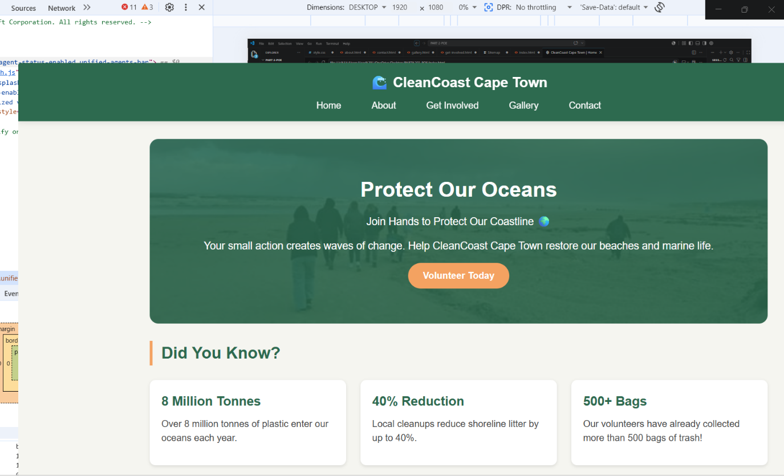

Tablet view
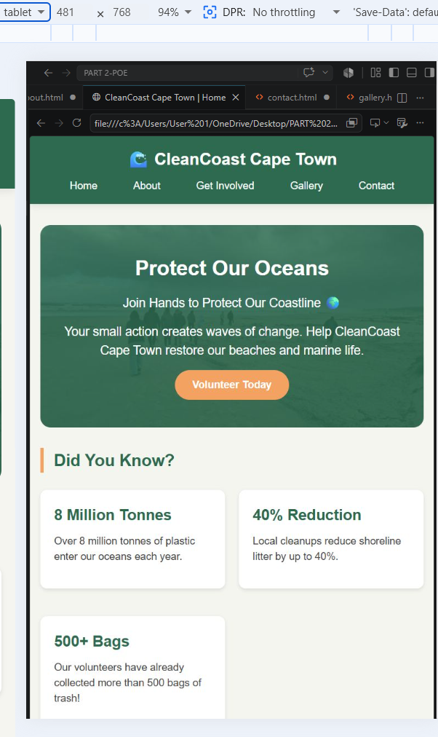

Mobile view
iPhone XR- 414 x 896
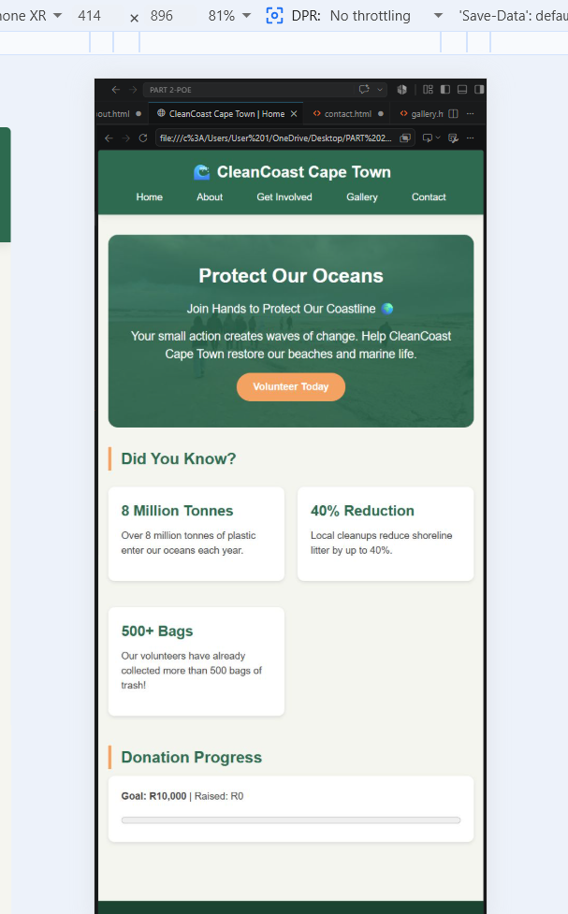

Contact – Mobile View
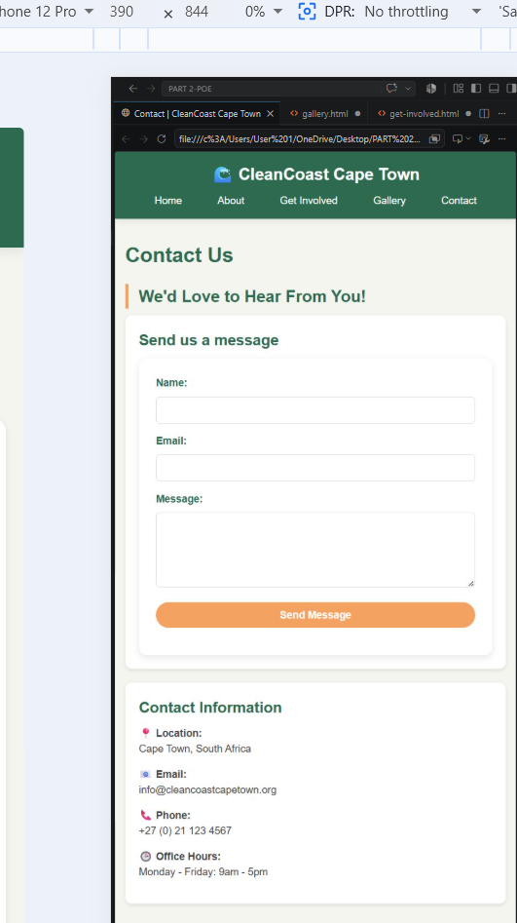

iPhone 12 Pro- 390 x 844
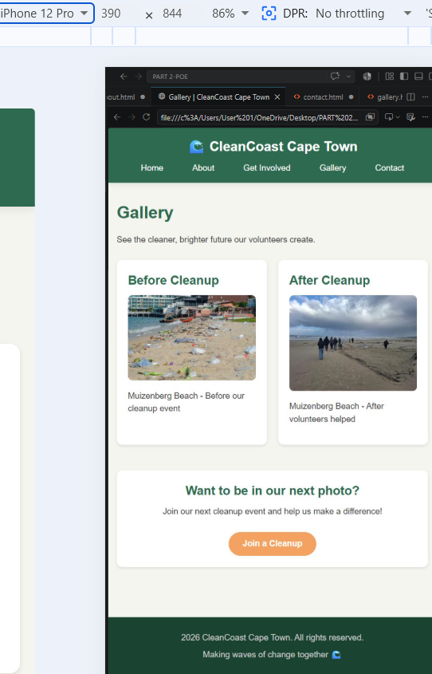

Laptop- 1366 x768
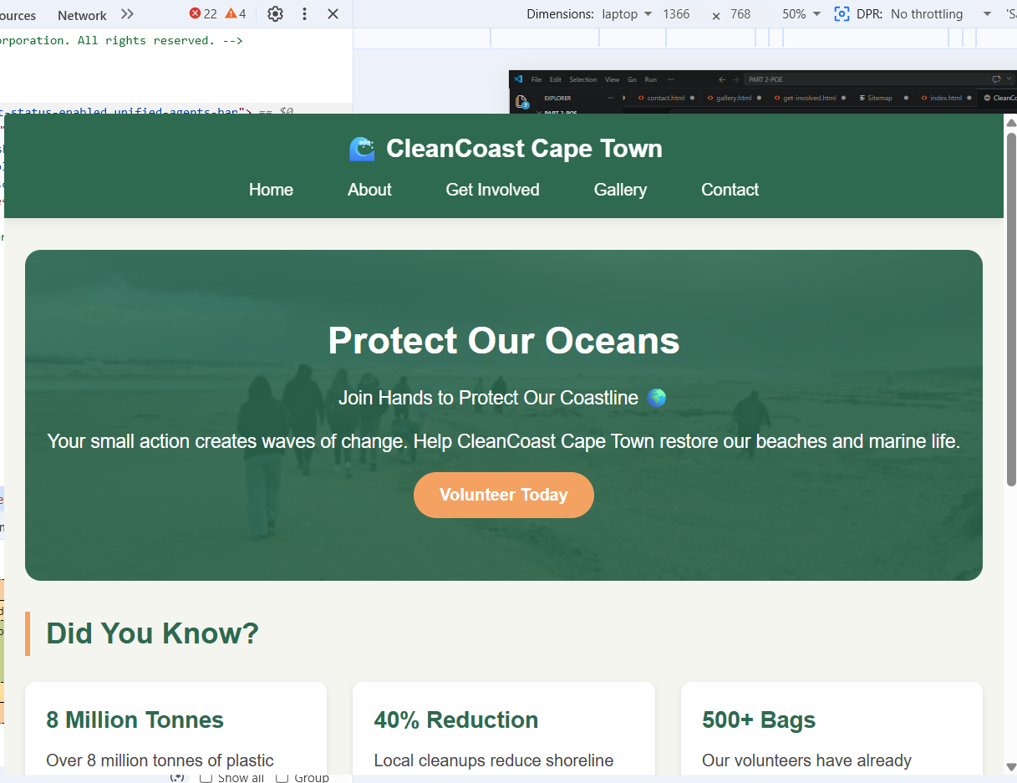

3.4 Testing and Iteration
I used browser developer tools to test my website on different devices and screen sizes:
Device | Screen Size | Status
Desktop | 1920 x 1080 | Working
Laptop | 1366 x 768 | Working
Tablet | 481 x 764 | Working
Mobile – iPhone 12 Pro | 390 x 844 | Working
Small Mobile - iPhone SE | 375 x 667 | Working

3.5 Screenshots of Different Screen Sizes
Desktop View (1920 x 1080) - Homepage:
The desktop view shows the full layout with the hero section, three cards in a row, and the donation progress bar. The navigation is horizontal at the top.
Desktop View - Navigation:
The navigation bar shows all menu items in a row with the orange hover effect on the active/current page.
Mobile View (390 x 844) - Homepage:
On mobile, everything stacks in one column. The navigation menu collapses and items stack vertically. Cards appear one below the other. The hero section text and button adjust to fit the smaller screen.
Mobile View - Navigation Menu:
The navigation menu stacks vertically on mobile so users can easily tap the links without zooming in. The hover effect still works when tapping.
Mobile View - Contact Form:
The contact form on mobile takes up the full width so inputs and buttons are easy to tap. Labels are above each input field for better readability.

PART 3: Enhancing Functionality and SEO

Working through Feedback from Part 2
After receiving my marks and feedback for Part 2, I went through all the comments carefully and made the following corrections and improvements:
Area of Feedback | What I Was Told | What I Changed | Where to Find It
No images showing | Images weren't displaying on the website | Fixed ALL image paths - used./Images/ instead of images/ | All HTML files
Changelog incomplete | Changelog was incomplete or missing | Created comprehensive changelog in README.md | README.md
Proposal continuation | Proposal needed to cover Parts 1-3 | Created complete proposal covering all parts | Proposal document
Little to no updates based on feedback | Not enough changes made from previous feedback | Made comprehensive changes documented in changelog | All files
Follow submission instructions | Need to follow all instructions | All files in correct format and structure | All submissions
Make use of rubric | Follow the rubric provided | Verified against rubric for all parts | All files

CleanCoast-Cape-Town/
│
├── index.html ← Homepage (with donation progress bar)
├── about.html ← About page (with accordion team bios)
├── get-involved.html ← Get Involved page (with volunteer form)
├── gallery.html ← Gallery page (with lightbox)
├── contact.html ← Contact page (with contact form + embedded map)
│
├── robots.txt ← NEW - SEO file for search engine crawlers
├── sitemap.xml ← NEW - SEO file listing all pages
├── README.md ← Updated - Documentation with changelog
│
├── css/
│ └── style.css ← ALL CSS (base + responsive + interactive)
│
├── js/
│ └── script.js ← ALL JavaScript (accordion + lightbox + forms + donation)
│
└── Images/
├── cleanny.jpg ← Homepage hero background
├── after clean beach.jpg ← Gallery - after cleaning up
├── before dirty beach.webp ← Gallery - before cleanup
├── clean coast 1.jpg ← Gallery - volunteers in action
├── clean coast 2.jpg ← Gallery - team effort
├── clean coast 3.jpg ← Gallery - making a difference
└── volunteer.jpg ← Gallery - happy volunteers
└── Website Project Proposal (Parts 1-3)

7. AI Disclosure Annex

7.1 Purpose
Document the responsible use of AI tools during project development in accordance with IIE policies (IIE009, IIE023).

7.2 AI Usage Summary
Category | Tool Used | Description of Use | Student Verification Action
Research and Planning | ChatGPT (GPT-5) | Project page outlines and visual ideas | Selected suitable ideas and rewrote in own words
Code Assistance | ChatGPT | Example HTML/CSS/JS snippets – donation bar + spotlight | Revise and rewrite in VS Code; add comments and manual formatting
Language Editing | Grammarly + ChatGPT | Grammar and clarity for proposal and README | Proofread and confirm academic tone
Documentation | ChatGPT | Assisted AI Annex layout format | Edited to fit IIE template and verified accuracy

7.4 Student Declaration
I confirm that the listed AI tools were used only to support learning and idea generation.
All content has been reviewed, paraphrased, and finalized by me, and the final submission represents my own work in compliance with The IIE’s Intellectual Integrity and Property Rights Policy.
Signature: ______________________ Date: _20-06-2026____________

8. Annex Summary
This annex ensures full transparency in AI-assisted development and demonstrates how ethical use of digital tools supports independent learning and skill development in web design.

